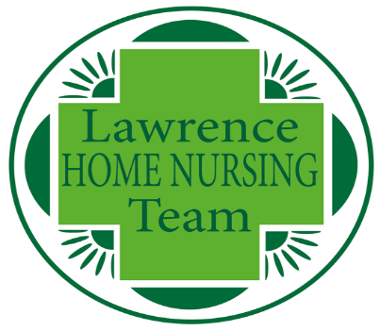

Lawrence Home Nursing Team
Treasurers report AGM 14 Oct 2020
- Significant changes over the last period
  - As was reported in the 2019 AGM the intent was to incorporate as a charity in 2020. We ceased “operating” as Lawrence Home Nursing Team on 30 June and commenced with Lawrence Home Nursing Team Limited on 1 July. Our objectives and our goals remain the same.
    - We provide people with end of life nursing care in their own homes. We look after anyone, aged 18 and over, who is in their last weeks of life. Free of charge.
  - The accounts being presented today are therefore for a 15 month period which took us from 1 April 2019 to 30 June 2020.
  - We are in the process of transferring the assets (investments) from the original charity to the Limited charity. When this process is complete the original charity will be formally closed.
  - We have implemented a new accounting system more suitable to our requirements.
  - We have documented and improved our financial controls policy
  - We have opened new bank accounts in the name of the limited charity.
- The charity is not required to have a formal audit but does have an “independent review”. As approved at the last AGM, this was performed by Astral Accountancy Services Ltd.
  - The charity is in a sound financial position which has reserves at a level which would allow us to run for at least 12 months without income should the need arise.
  - The independent review is “clean” and they are no concerns or matters in connection with the examination to which attention should be drawn to enable a proper understanding of the accounts to be reached.

To receive and adopt the independently reviewed accounts
- As highlighted in the Chairman’s report we live in strange times. Our nursing team has worked more hours than previously and our fundraising activities has by curtailed by social distancing requirements. We have a combined balance of £88k cash on deposit at the bank today (14 Oct) for Lawrence Home Nursing Team Ltd and the original charity. This is higher than usual (target between £40k and £60k for operational expenditure) to avoid any risk from investing in longer term investments for a potentially short period.
- The accounts are presented as part of the AGM. The accounts will also be published on our web site. However, the main figures are:
  - We had an operating deficit of £44,325 for the 15 month period from 1 April 2019 to 30 June 2020. Please note that this includes a transfer of funds to the incorporated charity of £108,497. The net position would therefore have shown an operating surplus of £64,172
  - We had a loss on the value of investments over the same period of £326,990
  - This has a net expenditure for the 15 month period of £371,315
  - The total funds on the balance sheet at 30 June 2020 was £1,483,228. The additional £108,497 is held in Lawrence Home Nursing Team Ltd and excluded from this figure).

To consider the budget for the period 1 July 2020 – 31 March 2021
- Expenditure for the 15 months to 30 June (excluding the transfer to the incorporated charity) was £380k. This has an annualised run rate of £304k.
- Proposed Budget for 9 months ending 31 March 2021 is £307k. This is an annualised run rate of £409k.
  - The main differences are an increase in nursing and associated staff costs due to increased demand and enlarged catchment area and a reduction in the fixed/semi fixed costs which reflect the shorter 9 month period.

To nominate an independent reviewer for the period 1 July 2020 – 31 March 2021
- We are proposing to move to Ellacotts following the incorporation of the charity.
  - Due diligence has been performed and reference calls with existing charitable companies have been executed with positive feedback.
  - T’s and C’s with pricing have also been reviewed
- https://www.ellacotts.co.uk/
- Countrywide House
23 West Bar Street
Banbury
Oxfordshire
OX16 9SA

